LAB 13: Creating LL (1) parse table for a given CFG and hence simulating

LL (1) Parsing

Inputted CFG



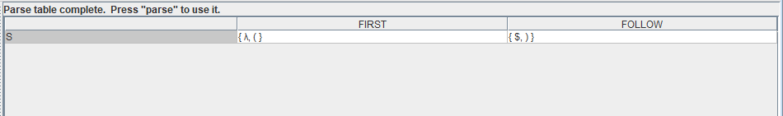First and Follow

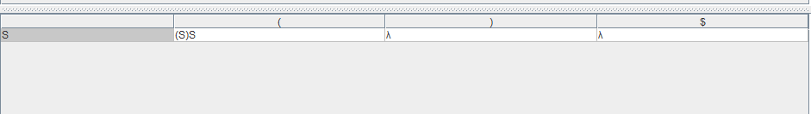Parse Table

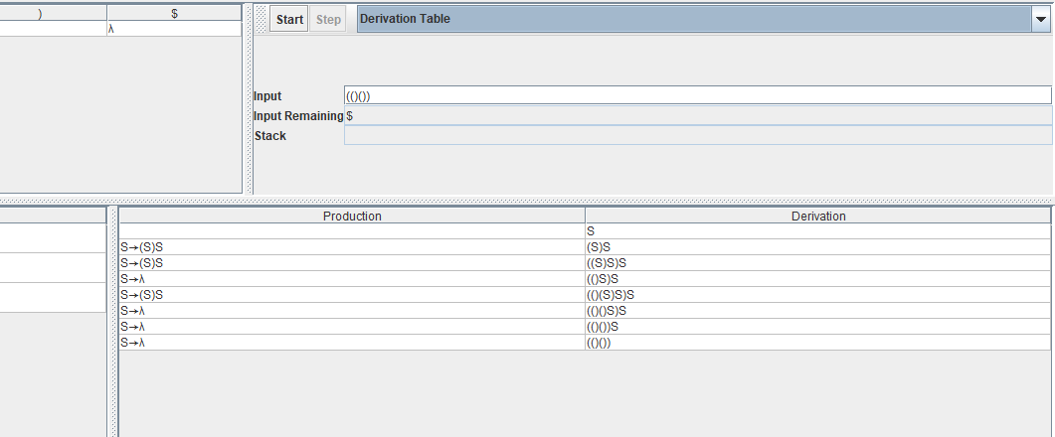Checking for input

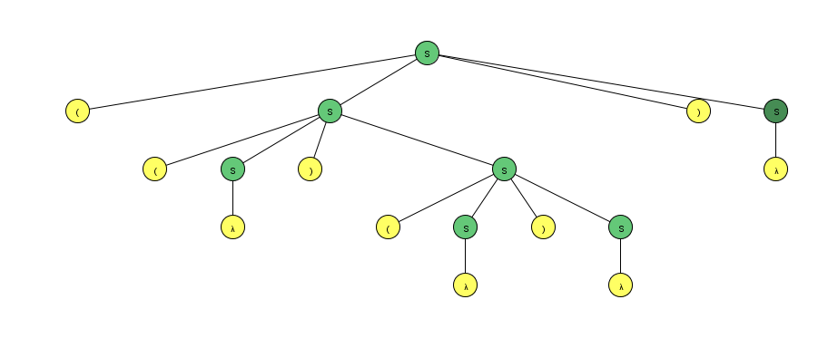

Hence, the input string is accepted since there is $ left on the input and nothing on the stack